ACE12425 Dinesh Gowtham K

**Azure Storage Account**

Azure storage account contains the azure storage data objects, blobs, files, tables and queues.

**Blob Storage** : To store unstructured data like images, videos, audios and documents.

**File Storage :** It’s a cloud based file storage that allows the applications to access and store files using the SMB (Server Message Block) protocol.

**Queue Storage** : It provides a fully managed cloud-based service for storing and retrieving large number of messages.

**Steps to create storage account**

1. Login into the azure portal and search for the service storage account and click on it.
2. In storage account, click on the Create Storage account.
3. Fill the mandatory details like Resource group name, storage account name.

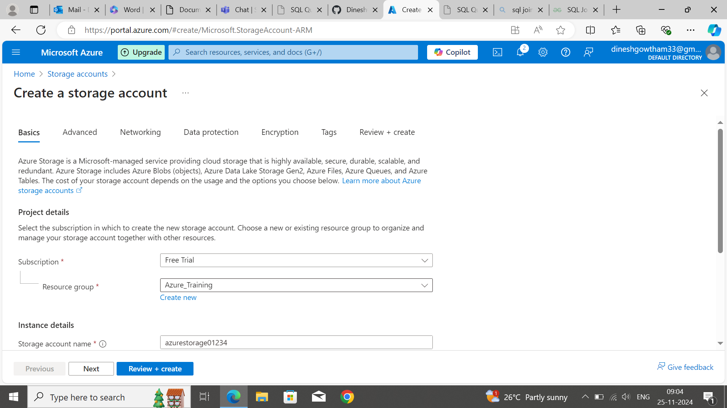

1. By selecting the primary service, the storage account created will be based on that like whether it should be based on blob or files or queues.

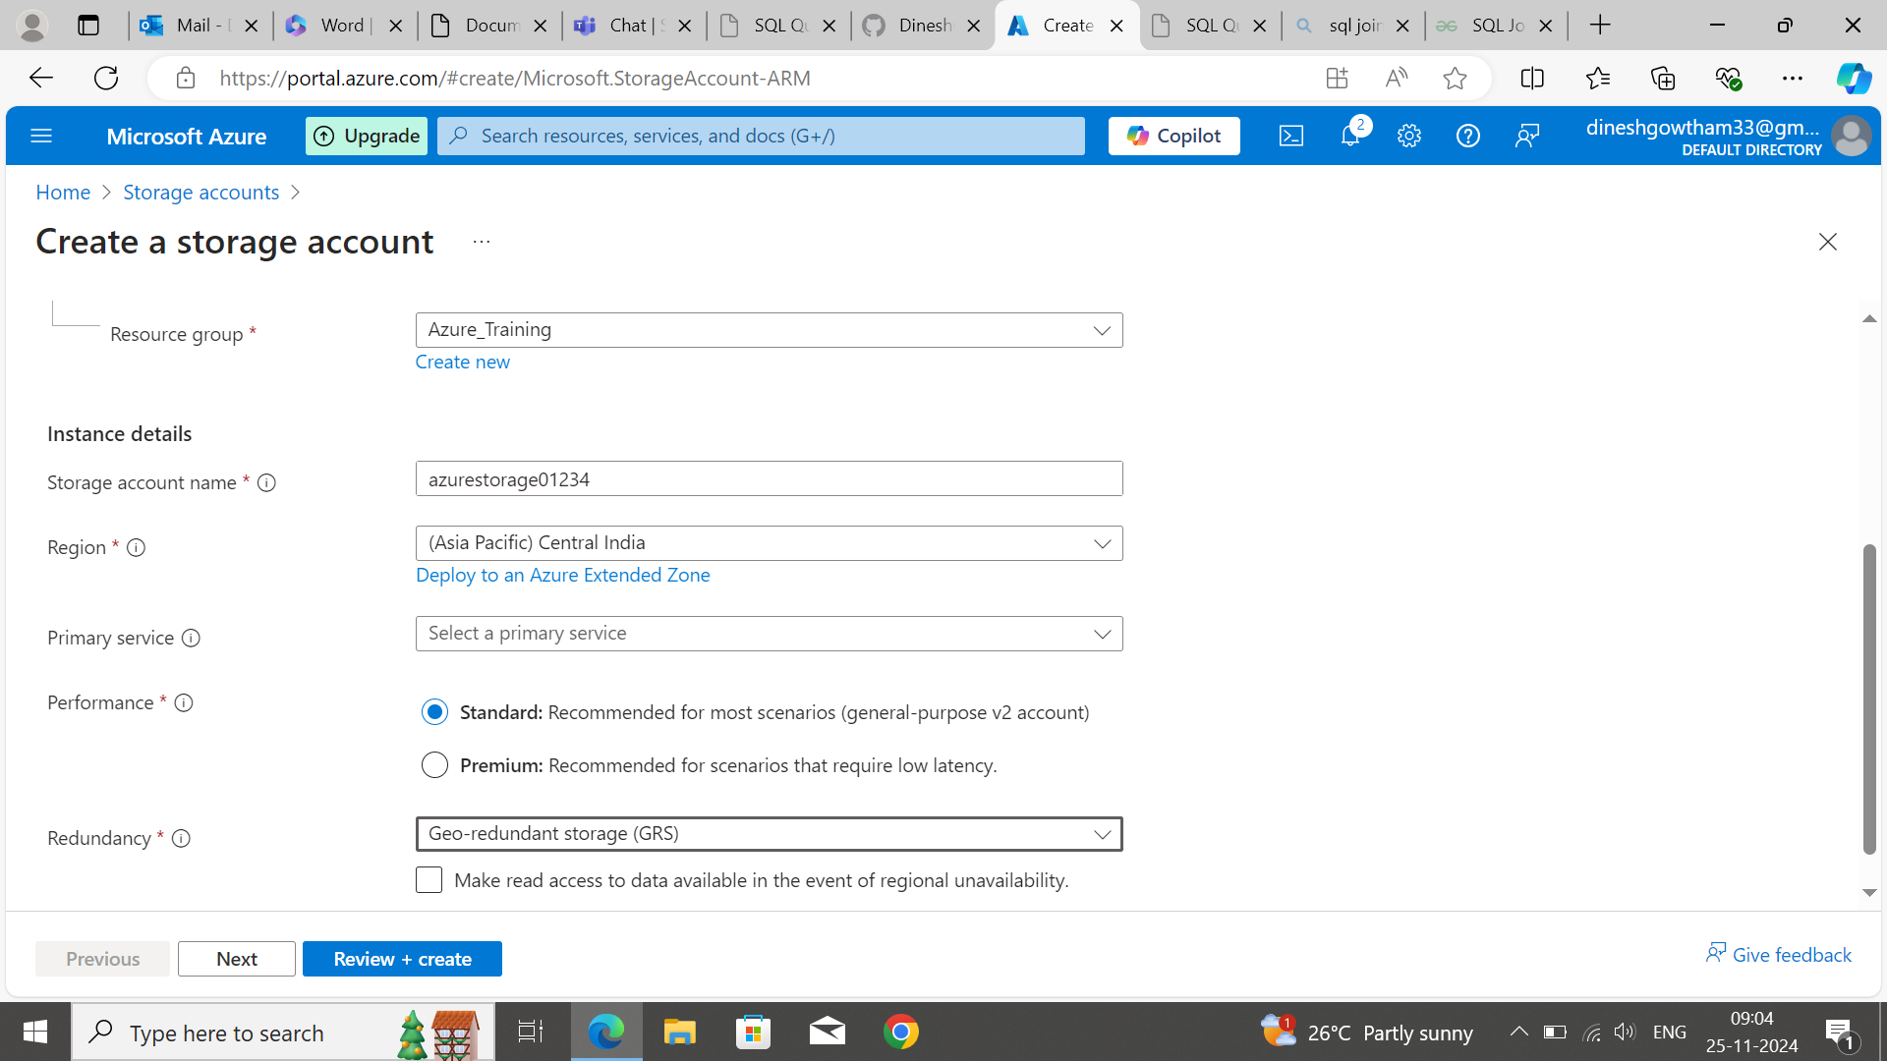

1. Fill the security details, access protocols, tracking , recovery and encryption.

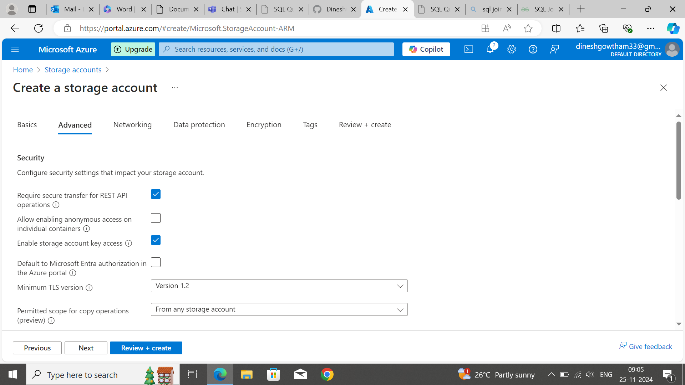

1. Most of the details were set as default because few options are paid.

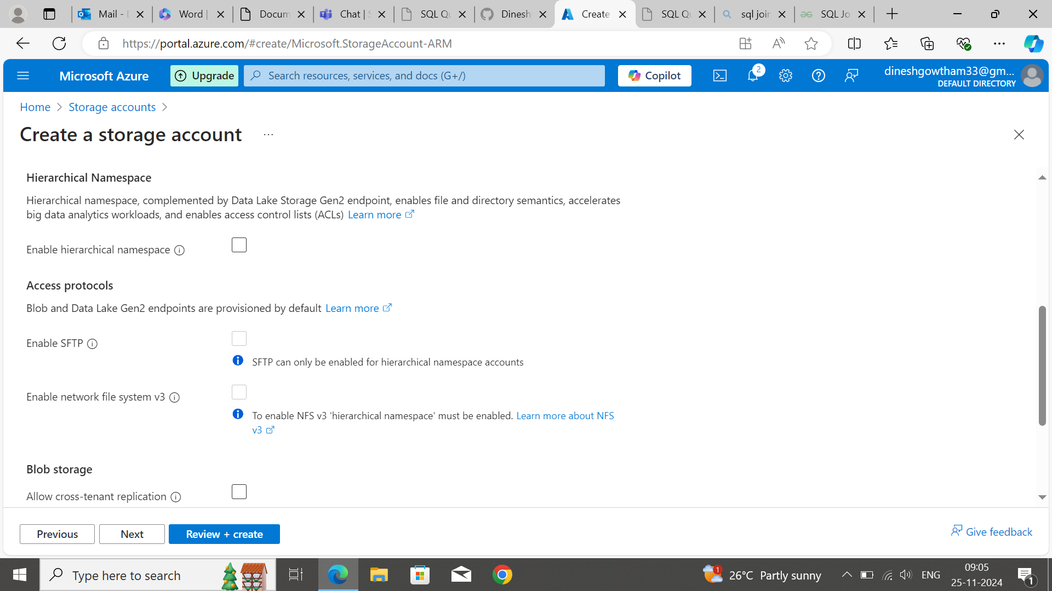

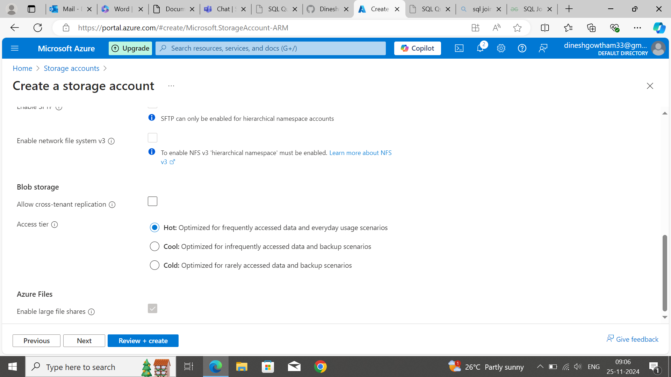

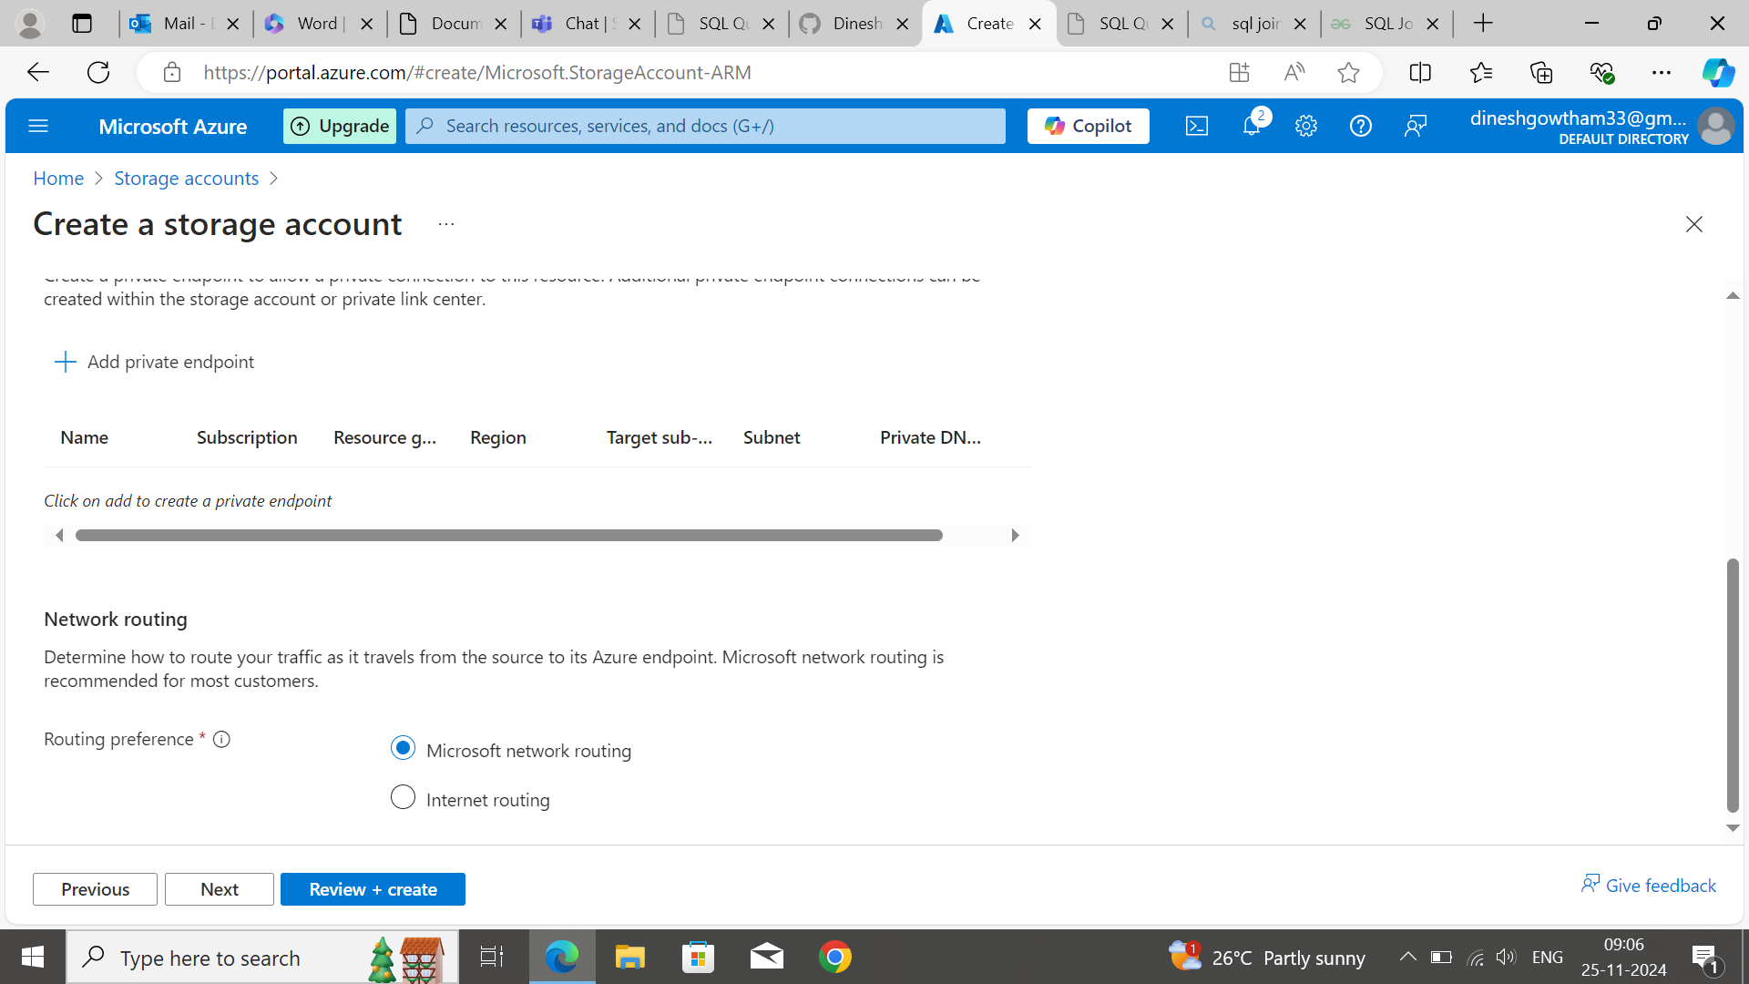

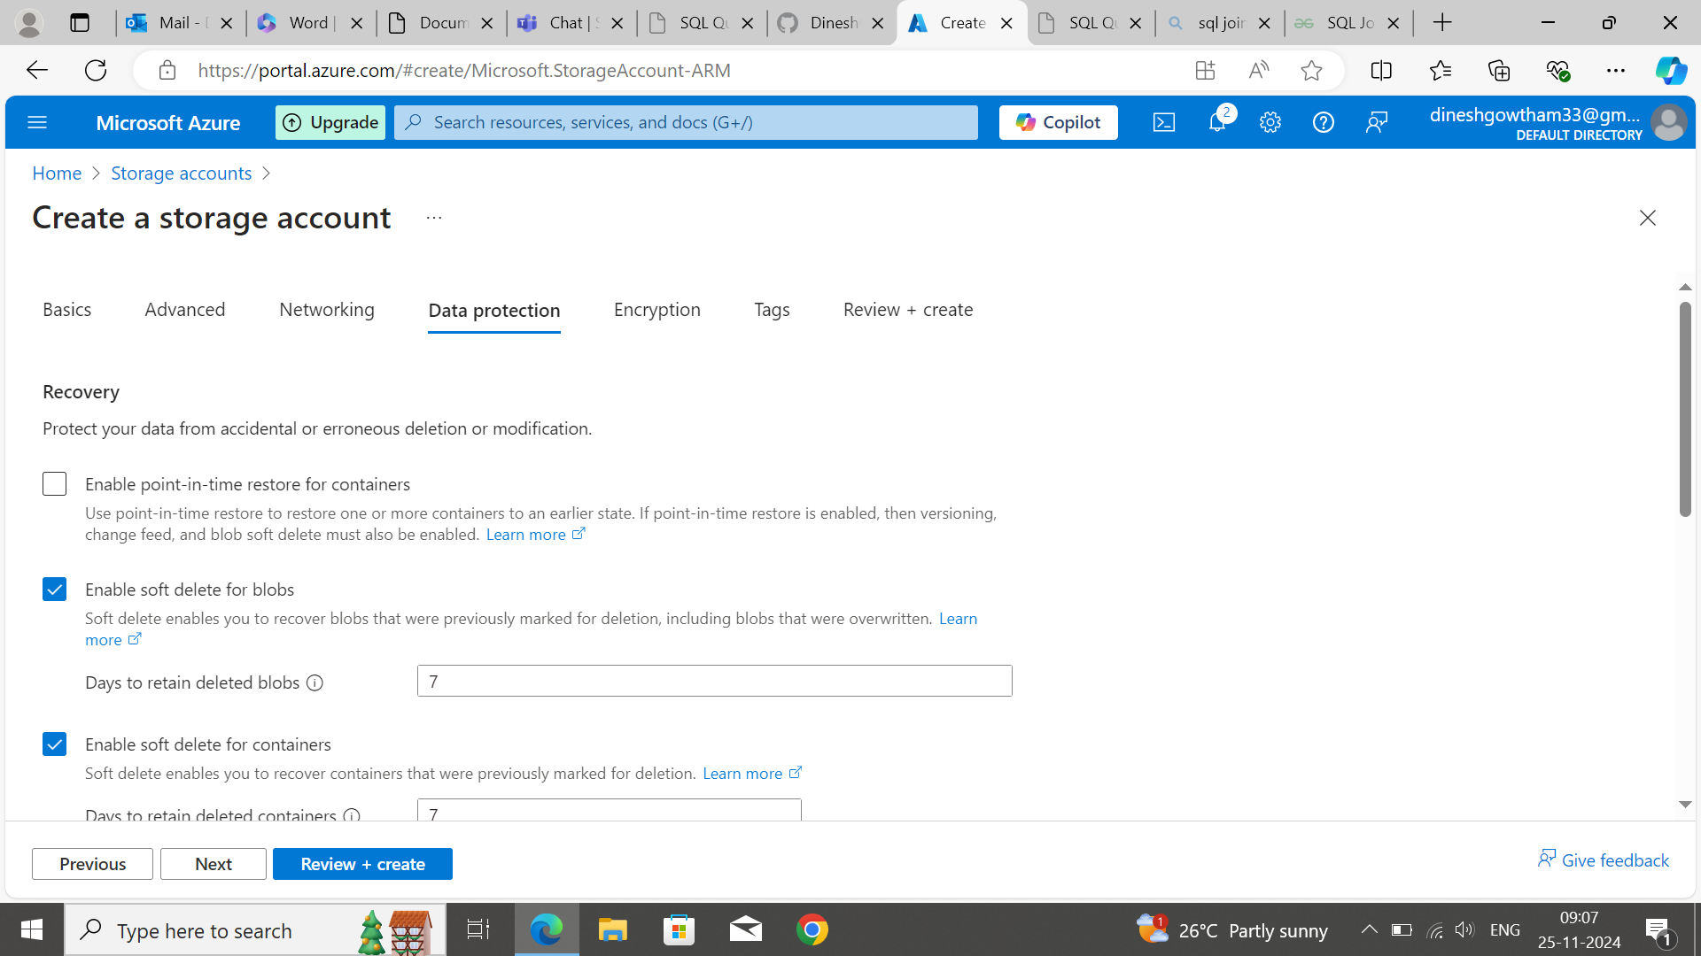

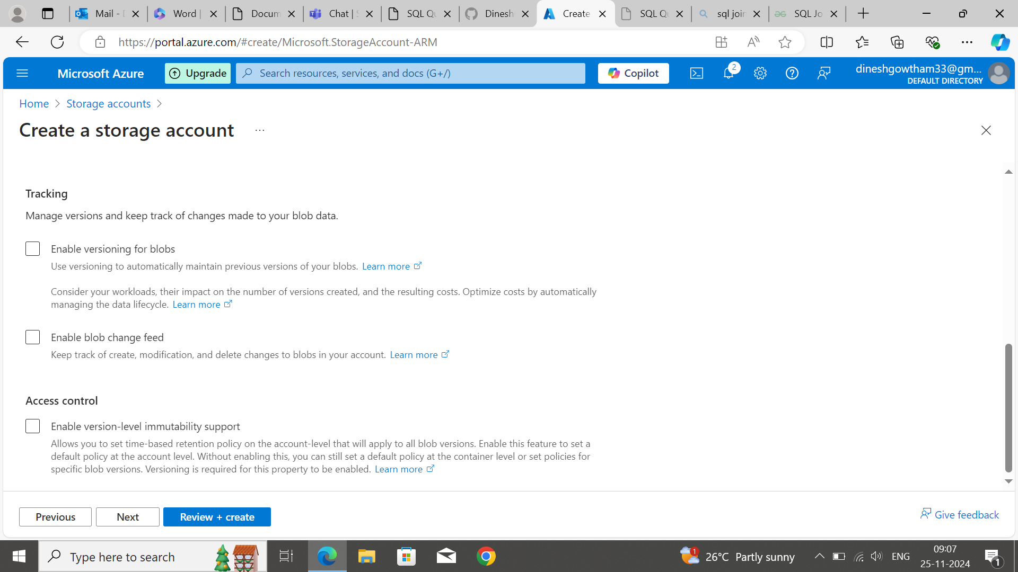

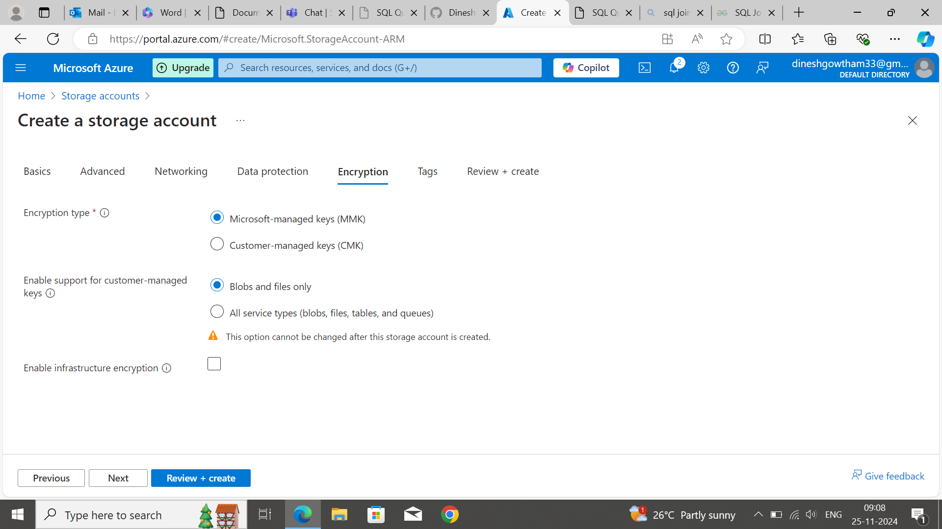

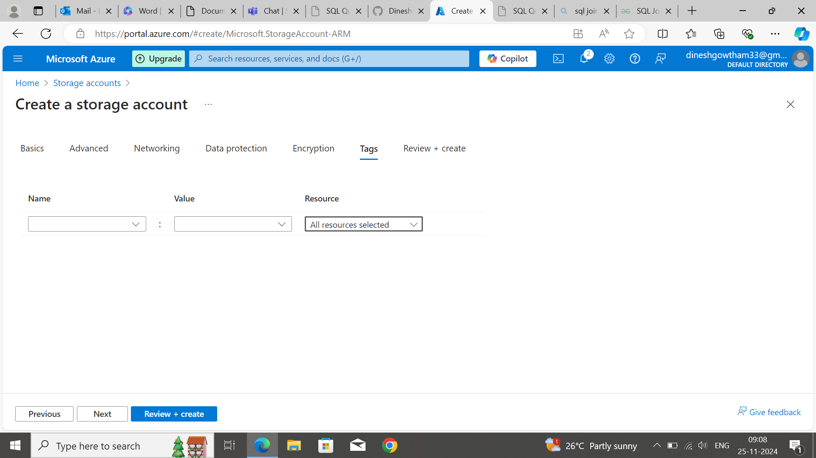

After Filling the details click on Review and create. Once you

clicked create, the deployment process will start.

The Properties of the storage account will be displayed after

successful deployment.

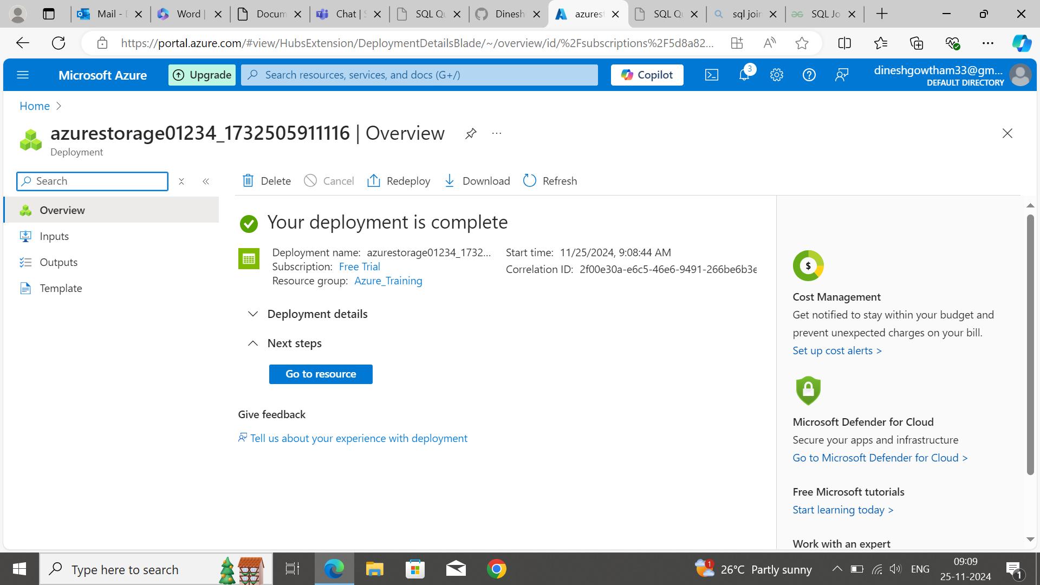

Click Upload , create a new conatiner and upload the files in it.

To view the uploaded files, go to data storage and click

container.

You can see the new container created. Click the container and

you can view the uploaded file.

